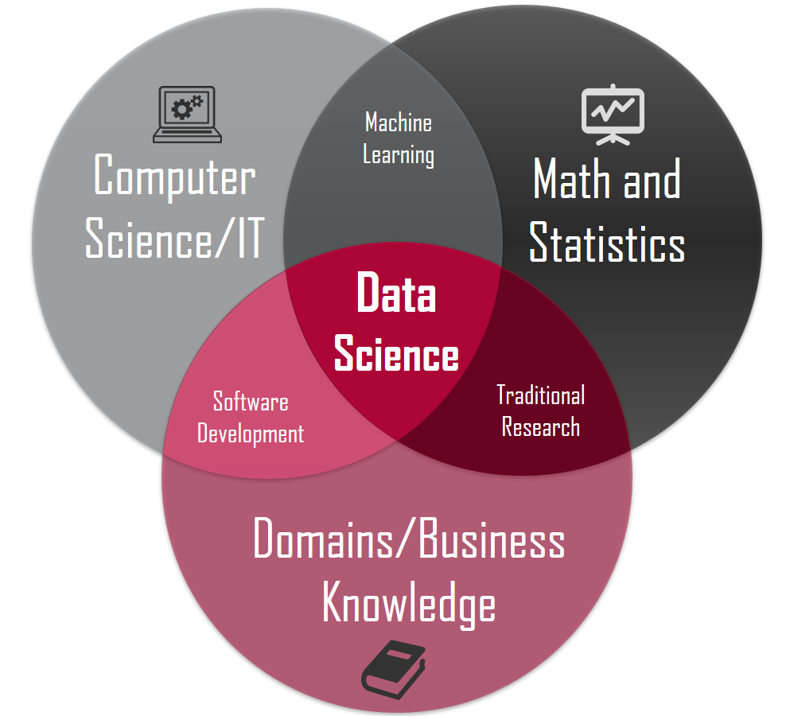

Stats & Data

R & Python

Excel & Tableau

Interdisciplinary field that uses scientific methods, processes, algorithms, and systems to extract knowledge and insights from many structural and unstructured data. Related to data mining and big data.